**The** true impact of space is felt downstream

***Published:***

*16 December 2019*

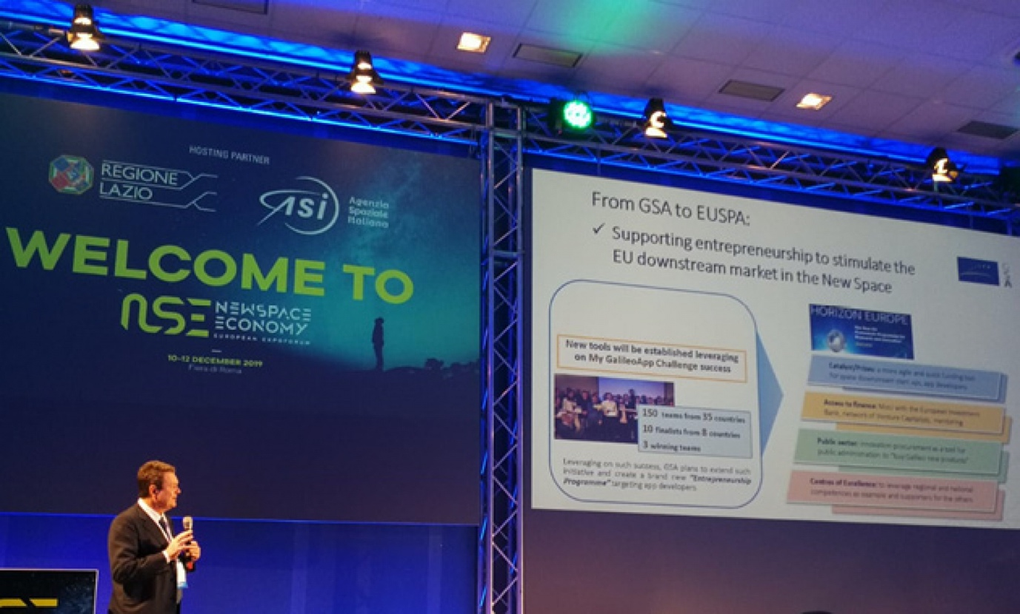

*Space is driving innovation and supporting service delivery across the global economy*

**The upstream space market, with its rocket launches and high-tech satellite payloads, may seem at a first glance to be the most exciting segment of the space industry. But when it comes to innovation, job and revenue creation and the provision of services that change people’s lives for the better, the downstream market is where the action is. This was the key message delivered by European GNSS Agency (GSA) Executive Director Carlo des Dorides at the New Space Economy forum in Rome on December 12.**

We are living in the Golden Age of GNSS. Space-based technology is driving innovation and supporting service delivery in almost all sectors of the global economy – from agriculture and transport to healthcare and telecoms. Satellites and the location-based services that they enable are transforming the way that we live and work.

**Downstream driving the space economy**

Delivering a keynote address on GNSS markets, applications and data at the NSE forum, the GSA Executive Director noted that downstream users are directly benefitting from Galileo. “Over 50,000 jobs are supported annually in the downstream GNSS industry,” des Dorides said, adding that European companies account for 27% of the global GNSS market and that this share is set to grow.

“GNSS downstream is driving the space economy. Global revenue generated by the GNSS downstream market is forecast to reach EUR 150 billion in 2019 and increase to EUR 325 billion in 2029,” des Dorides said, citing the latest edition of the [GSA GNSS Market Report](https://www.gsa.europa.eu/market/market-report). “Over 50% of this GNSS revenue comes from added-value services,” he said.

**Read this:** [Europe’s economy is increasingly dependent on space](https://www.gsa.europa.eu/newsroom/news/europe%E2%80%99s-economy-increasingly-dependent-space-itre-committee-hears)

With the evolution of the GSA into the European Agency for the Space Programme (EUSPA) it will be possible to fully exploit synergies between the EU space programmes to deliver applications and services in a wide range of sectors, from security and emergency response, to urban planning, agriculture and energy and critical infrastructure, des Dorides said.

“With its expanded mandate, the GSA will continue to support entrepreneurship and stimulate the EU downstream market to deliver applications with tangible social benefits, such as improved environmental performance, better transport efficiency and more effective emergency response,” he said.

**Driving innovation in transport**

One sector in particular in which new possibilities are opening up is road transport, which is a huge GNSS market segment. The road segment is forecast to dominate all other market segments and account for 93.3% of cumulative revenue in 2019-2029. In her keynote at the NSE forum, the GSA’s Head of Market Development Fiammetta Diani spoke about GNSS and the road sector and, in particular, the state of play in autonomous vehicles.

Noting that almost 97% of new vehicles are equipped with GNSS-enabled in-vehicle systems, which provide PNT for a wide range of in-vehicle applications, Diani said that these systems are currently able to support navigation, remote diagnostics and assisted driving. “In the future, IVS will support even more complex applications, including automated driving,” she said.

**And this:** [First Galileo-enabled autonomous vehicle successfully demonstrated](https://www.gsa.europa.eu/newsroom/news/first-galileo-enabled-autonomous-vehicle-successfully-demonstrated)

In terms of the state of play with autonomous driving, the GSA’s Head of Market Development said that preparations are currently underway for Level 4. At this level, a highly automated vehicle performs all driving tasks and monitors the environment under limited conditions, but the driver may still be required to intervene. Level 4 is the penultimate stage before full automation at Level 5.

Diani also noted the recent live demonstration of a Galileo-enabled autonomous vehicle. As part of this demonstration, a Renault ZOE electric car fitted with an innovative positioning engine developed by the ESCAPE project was autonomously driven on tracks at the University of Technology and on public roads in Compiègne, France. The EGE leverages Galileo signals and services to provide a core positioning component in autonomous vehicles.

"This successful test of the ESCAPE positioning engine based on Galileo, at automation Level 4, means that we are getting closer to provide the high accurate and reliable absolute positioning that will be needed for full automation,” she said.

More generally, Galileo will support new road safety functions that will become mandatory from 2022, including accident data recording, intelligent speed assistance, lane keeping assistance and vulnerable road user detection.